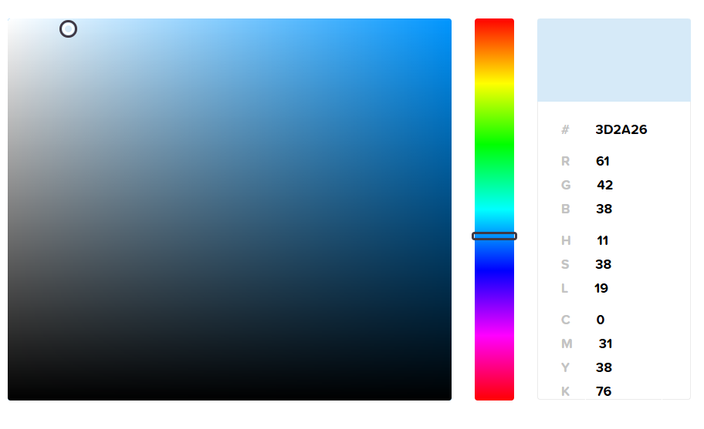**Color Codes – HTML \ CSS**

**Color Picker**

**Find that perfect color with our**[**color picker**](http://htmlcolorcodes.com/color-picker/)**and discover beautiful color harmonies, tints, shades and tones; input Hex color codes, RGB and HSL values, and generate HTML, CSS and SCSS styles.**

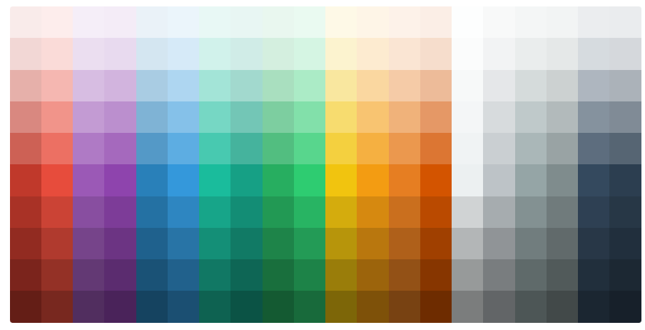

[**Color Chart**](https://htmlcolorcodes.com/color-chart/)

**This**[**color chart**](http://htmlcolorcodes.com/color-chart/)**features flat design colors, Google's Material design scheme and the classic web safe color palette, all with Hex color codes.**

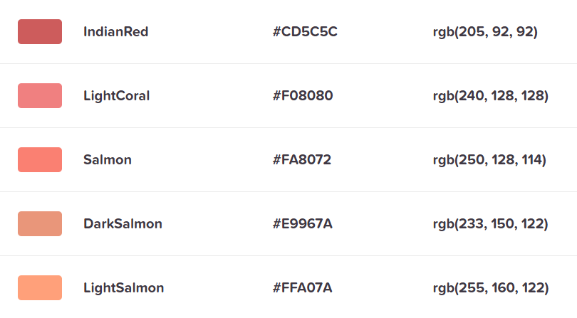

[**Color Names**](https://htmlcolorcodes.com/color-names/)

**The purpose of this color guide is for a quick reference of all the HTML color names grouped by color.**

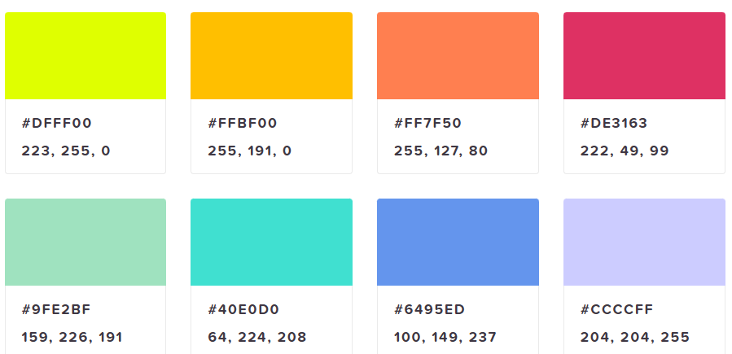

[**Color Library**](https://htmlcolorcodes.com/colors/)



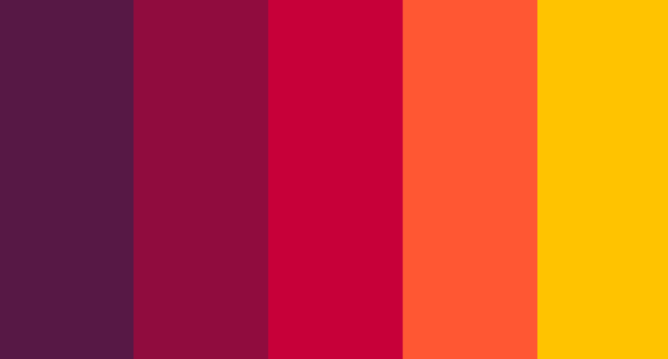

**List of common HTML colors**



